School of Engineering
My Project Title Goes Here

First Name Last Name (ID) | First Name Last Name (ID)
First Name Last Name (ID) | First Name Last Name (ID)
Supervised by: Dr. Author

Submitted in partial fulfillment of the requirements of B.Sc. Degree in Electrical Engineering
April 20, 2016

Students Statement

We, the undersigned students, certify and confirm that the work submitted in this project report is entirely our own and has not been copied from any other source. Any material that has been used from other sources has been properly cited and acknowledged in the report.
We are fully aware that any copying or improper citation of references/sources used in this report will be considered plagiarism, which is a clear violation of the Code of Ethics of the University of Jordan.
In addition, we have read and understood the legal consequences of committing any violation of the Universityof Jordan Code of Ethics.

First Name Last Name (ID) | First Name Last Name (ID)
First Name Last Name (ID) | First Name Last Name (ID)

Supervisor Certification

This to certify that the work presented in this senior year project manuscript was carried out under my supervision, which is entitled:

“My Project Title Goes Here”
First Name Last Name (ID) | First Name Last Name (ID)
First Name Last Name (ID) | First Name Last Name (ID)

Dr. Name of Supervisor,

Examining Committee Evaluation Guidelines

Abstract and Introduction | L M H
Abstract is complete, concise, specific and Self-sufficient | ⃝⃝⃝⃝
Stating problem definition and objectives of work | ⃝⃝⃝⃝
Providing background information | ⃝⃝⃝⃝
Presenting methods used in solution | ⃝⃝⃝⃝
Including previous work and citation | ⃝⃝⃝⃝
Methodology
Effectiveness of the proposed solution | ⃝⃝⃝⃝
Logical sequence or flow of report information | ⃝⃝⃝⃝
Technical content accuracy and engineering soundness | ⃝⃝⃝⃝
Results and Discussion
Results presentation or demonstration | ⃝⃝⃝⃝
Results analysis and interpretation | ⃝⃝⃝⃝
Sample calculation, error analysis, and trend analysis | ⃝⃝⃝⃝
Use of graphs and illustrations
Conclusions and Future work
Stressing the significance of the work | ⃝⃝⃝⃝
Interpreting the results and the implications of the results | ⃝⃝⃝⃝
Including directions or actions to be taken for future work | ⃝⃝⃝⃝
ABET and References
Impact of Eng. solutions: global, economical, environmental and societal | ⃝⃝⃝⃝
Implementation of citation / referencing and references quality | ⃝⃝⃝⃝

Examining Committee Member
Remarks and Notes

DEDICATION

This is where you should thank people if you wish. Make it short – no more than two short paragraphs. You may also call this part Acknowledgements if you desire.

SYMBOLS AND ABBREVIATIONS

This is where you should put all the symbols used and abbreviations(must be sorted). It is stored in a table format same as the table of contents. Use inserts a row to add more entries….etc
ABET | Accreditation Board For Engineering And Technology
DB | Department Board
EC | Examining Committee
FAC | Format Adherence Committee
HATS | HATS Methodology: Headings, Access, Typography, and Spacing
PC | Project Committee
α | Angular acceleration rad/s²
ξ | Damping ratio

ABSTRACT

The abstract is an overview that provides the reader with the main points and results, though it is not merely a listing of what the report contains. It is a summary of the essence of a report. For this reason, it should be crafted to present the most complete and compelling information possible. It is not a detective story building suspense as the reader hunts for clues, and should not be vague or obtuse in its content.
A well-written abstract should state what was done and what results were found in a concise or short way (two to three paragraphs and less than 300 words). It also should avoid vagueness by stating specific results and be informative. Typically, it is self-sufficient and does not refer to the body of the report and it should make useful recommendations. Finally, it uses past tense to report what was done.

TABLE OF CONTENTS
- INTRODUCTION | 1
- BACKGROUND | 2
- METHODS / PROCEDURES | 3
- RESULTS AND DISCUSSION  - MACHINE MAINTENANCE  - MACHINE FAILURE | 4  4  5
- IMPACT OF ENGINEERING SOLUTIONS  - OVERVIEW  - IMPACT TO SOCIETY | 6  6  7
- CONCLUSIONS | 8
- REFERENCES | 10
- APPENDICES | 11

CHAPTER ONE
INTRODUCTION

The introduction states the problem and its significance, states the technical goals of the work, and usually contains background information that the reader needs to know in order to understand the report. Consider, as you begin your introduction, who your readers are and what background knowledge they have. For example, the information needed by someone educated in medicine could be very different from someone working in your own field of engineering.
The introduction might include any or all of the following.
- Problems that gave rise to the investigation
- The purpose of the assignment (what the writer was asked to do)
- History or theory behind the investigation Literature on the subject
- Methods of investigation

CHAPTER TWO
BACKGROUND

This chapter gives the theory or previous work on which the experimental work is based if that information has not been included in the introduction. Make sure to cite your sources of information and list the references in that back.

CHAPTER THREE
METHODS / PROCEDURES

This section describes the major pieces of equipment used and recaps the essential step of what was done. In scholarly articles, a complete account of the procedures is important. However, general readers of technical reports are not interested in a detailed methodology. This is another instance in which it is necessary to think about who will be using your document and tailor it according to their experience, needs, and situation.

CHAPTER FOUR
RESULTS AND DISCUSSIONS

This chapter presents the data or the end product of the study, test, or project and includes tables and/or graphs and a brief interpretation of what the data show. When interpreting your data, be sure to consider your reader, what their situation is and how the data you have collected will pertain to them.
During discussions one explains what the results show, analyzes uncertainties, notes significant trends, compares results with theory, evaluates limitations or the chance for faulty interpretation, or discusses assumptions. The discussion section sometimes is a very important section of the report, and sometimes it is not appropriate at all, depending on your reader, situation, and purpose. Please note that you may separate this chapter into two separate ones; namely results and discussions, respectively.
It is important to remember that when you are discussing the results, you must be specific. Avoid vague statements such as “the results were very promising.”

4.1 Machine Maintenance
Preventive maintenance could periodic or condition based, which depends on which parameters one uses to schedule the maintenance. In periodic or calendar based preventive maintenance …. Figure 4.1 illustrates the difference between an inspection and a service [2].

Periodic Inspection
Periodic Mechanical Service
Periodic Maintenance
Restore Deterioration
Measure Deterioration

Figure 4.1: Periodic maintenance – inspection versus service

4.2 Machine Failure
A good example on some of the machines that will definitely have a good room for improvement is depicted in Figure 4.2. Once this machine shined and organized one may identify future sources of failures by catching them in early stages.

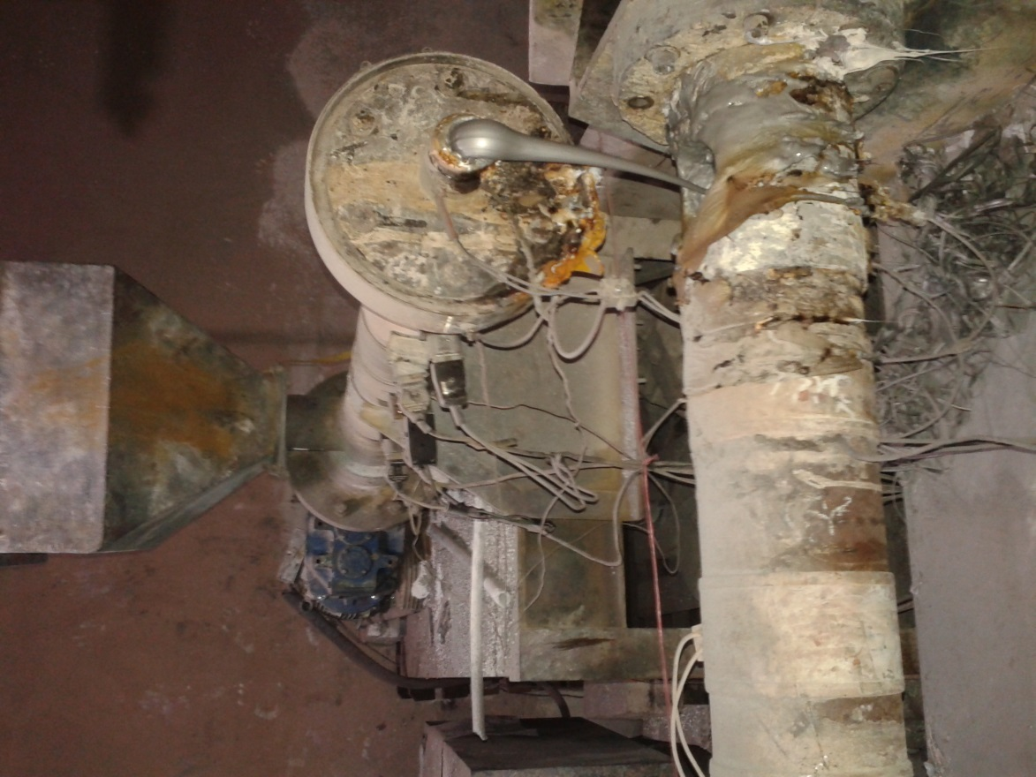
Dusty Environment
Tangled heater wires

Figure 4.2: Color Master Batch dirty machine

CHAPTER FIVE
IMPACT OF ENGINEERING SOLUTIONS

This chapter is mandatory and it is an ABET requirement that is needed to fulfil criterion ‘h’ and it is a senior year project outcome. Students need to demonstrate the impact of their engineering project solutions in a global or/and economicalor/and environmentalor/and societal context.
5.1 Overview
Suppose that you senior year project is about using alternative energy. Then you may want to demonstrate the impact on the environment in terms of low emissions and pollutions ….etc. Also, you may show economic benefits and compare it with other fuels…etc
5.2 Impact to Society (Discuss)
Show how your project impacts society. You maychange the section title to reflect impact to other needed parts such as global or/and economicalor/and environmentalor/and societal context…etc.
As an example on environmental impact, refer to Figure 5.1, which shows the production of Nox [2]. The impact of releasing NOx to the environment….etc.
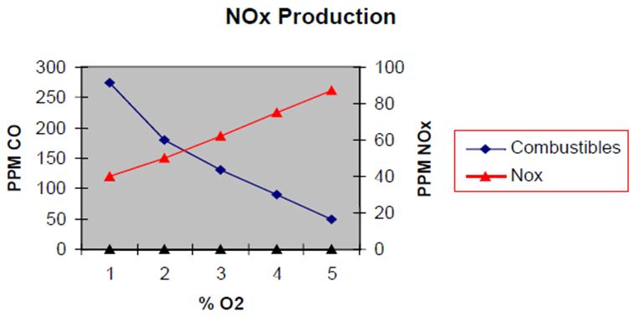
Figure 5.1: NOx production in Gas Turbine

CHAPTER SIX
CONCLUSIONS

This section interprets the results and is a product of thinking about the implications of the results. Conclusions are often confused with results. A conclusion is a generalization about the problem that can reasonably be deduced from the results.
Be sure to spend some time thinking carefully about your conclusions. Avoid such obvious statements as “X doesn’t work well under difficult conditions.” Be sure to also consider how your conclusions will be received by your readers, and as well as by your shadow readers—those to whom the report is not addressed, but will still read and be influenced by your report.
The recommendations are the direction or actions that you think must be taken or additional work that is need to expand the knowledge obtained in your report. In this part of your report, it is essential to understand your reader. At this point you are asking the reader to think or do something about the information you have presented. In order to achieve your purposes and have your reader do what you want, consider how they will react to your recommendations and phrase your words in a way to best achieve your purposes.
To feel the differences between Results, Conclusions, and Recommendations, assume that you were walking down the street, staring at the treetops, and stepped in a deep mud puddle while wearing expensive new shoes. What would be results, conclusions, and recommendations might you draw from this situation?
Some suggested answers follow.
Results: The shoes got soaking wet, the leather cracked as it dried, and the soles separated from the tops.
Conclusions: These shoes were not waterproof and not meant to be worn when walking in water. In addition, the high price of the shoes is not closely linked with durability.
Recommendations: In the future, the wearer of this type of shoe should watch out for puddles, not just treetops. When buying shoes, the wearer should determine the extent of the shoes’ waterproofing and/or any warranties on durability.

REFERENCES

[1] Saxby, G., 1996, Practical Holography, 2nd ed., Prentice Hall, New York, NY, Chap. 6.
[2] Dahl, G. and Suttrop, F., 1998, “Engine Control and Low-NOx Combustion for Hydrogen Fuelled Aircraft Gas Turbines,” Int. J. Hydrogen Energy, 23(8), pp. 695-704.
[3] Danish Wind Energy Association, n.d., March 23, 2015, from http://www.windpower.org/en/core.htm
[4] Leverant, G.R., 2000, “Turbine Rotor Material Design – Final Report,” DOT/FAA/AR-00/64, Federal Aviation Administration, Washington, D.C.
[5] Chan, D.C., 1996, ”Effects of Rotation on Turbulent Convection: Direct Numerical Simulation Using Parallel Processors,” Ph.D. thesis, University of Southern California.

APPENDICES

- Project Logbooks (sorted chronically)
- Raw Data (if applies)
- Long Processed Data (if applies)
- Long Mathematical proofs (if applies)
- Code (if applies)
- Datasheets (if applies)
- Project CD Soft Copy

